

Project Plan
Template

Document Control

Document Information
© | Information
Document Id | [Document Management System #]
Document Owner | [Owner Name]
Issue Date | [Date]
Last Saved Date | [Date]
File Name | [Name]

Document History
Version | Issue Date | Changes
[1.0] | [Date] | [Section, Page(s) and Text Revised]

Document Approvals
Role | Name | Signature© | Date
Project Sponsor

Project Review Group

Project Manager

Quality Manager
(if applicable)

Procurement Manager
(if applicable)

Communications Manager
(if applicable)

Project Office Manager
(if applicable)

Table of Contents

Template Guide 1
1 Planning Basis 2
1.1 Scope 2
1.2 Milestones 2
1.3 Phases 2
1.4 Tasks 3
1.5 Effort 3
1.6 Resources 4
2 Project Plan 4
2.1 Schedule 4
2.2 Dependencies 5
2.3 Assumptions 5
2.4 Constraints 5

3 Project Budget, Risk Log and Change Management 6
3.1 Project Budget 6
3.2 Risk Log 6
3.3 Change Management 6

4 Appendix 7

Planning Basis

Scope
The activities and tasks defined in the project plan must be undertaken within the scope of the project. For this reason, reiterate the scope of the project here as defined in the Project Charter.

Milestones
A milestone is “a major event in the project” and represents the completion of a set of activities. Examples of milestones include:

- Business Case approved
- Feasibility Study approved
- Project Charter approved
- Project Team appointed
- Project Office established.

List and describe the key project milestones within the following table:

Milestone | Description | Delivery Date
Business Case Approved. | The Business Case has been documented and was approved by the Project Sponsor. | xx/yy/zz

Phases
A phase is “a set of activities which will be undertaken to deliver a substantial portion of the overall project”. Examples include:

- Project Initiation
- Project Planning
- Project Execution
- Project Closure.

List and describe the major project phases within the following table.

Phase | Description© | Sequence
Project Initiation | Defining the project by developing a business case, feasibility study and Project Charter as well as recruiting the project team and establishing the project office. | Phase # 1

Tasks
A ‘task’ is simply an item of work to be completed within the project. List all tasks required to undertake each activity, within the following table:

Phase | Activity | Task | Sequence
Project Planning | Develop Quality Plan | Identify Quality Targets  Identify Quality Assurance Techniques  Identify Quality Control Techniques  Document Quality Plan | 1st  2nd  3rd  4th

Effort
For each task listed above, quantify the likely ‘effort’ required to complete the task.

Task© | Effort
Identify Quality Targets  Identify Quality Assurance Techniques  Identify Quality Control Techniques  Document Quality Plan | no. days  no. days  no. days  no. days

Resources
For each task identified, list the resources allocated to complete the task.

Task© | Resource
Identify Quality Targets  Identify Quality Assurance Techniques  Identify Quality Control Techniques  Document Quality Plan | name  name  name  name

Project Plan

Schedule
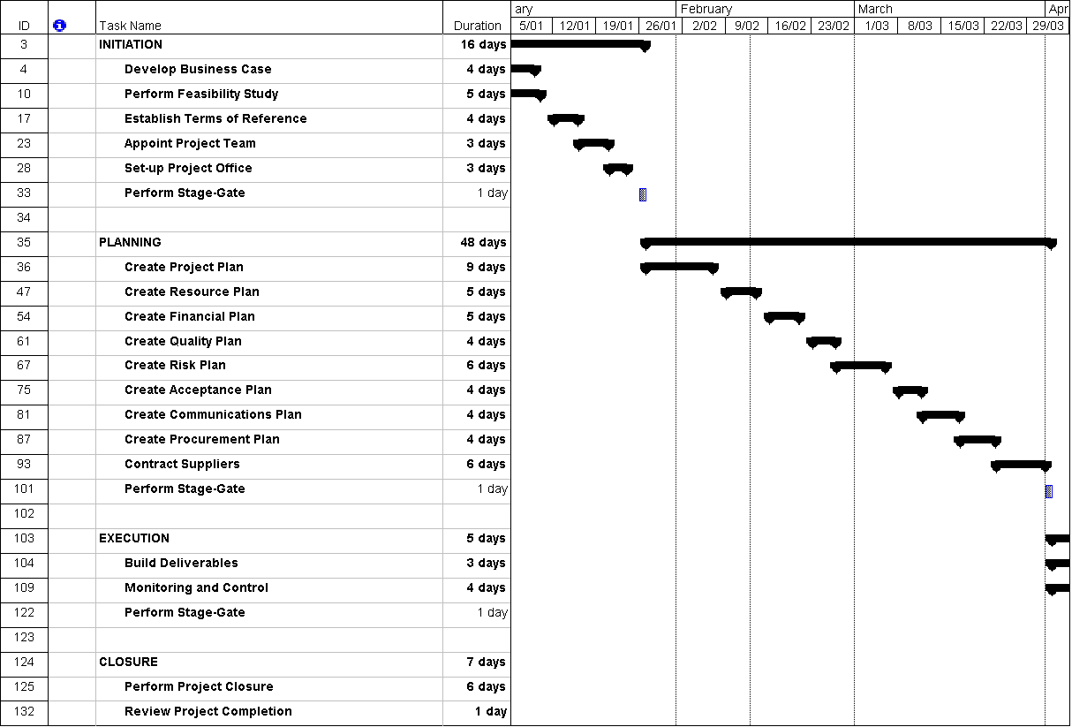
Provide a summarised schedule for each of the phases and activities within the project.

Note: Refer to the Appendix for a detailed project schedule.

Dependencies
‘Dependencies’ are logical relationships between phases, activities or tasks which influence the way that the project must be undertaken. Dependencies may be either internal to the project (e.g. between project activities) or external to the project (e.g. a dependency between a project activity and a business activity). There are four types of dependencies:
- Finish-to-start (the item this activity depends on must finish before this activity can start)
- Finish-to-finish (the item this activity depends on must finish before this activity can finish)
- Start-to-start (the item this activity depends on must start before this activity can start)
- Start-to-finish (the item this activity depends on must start before this activity can finish).

List any key project dependencies identified by completing the following table:

Activity | Depends on© | Dependency Type
Set-up Project Office | Appoint Project Team | Finish-to-start

In the example given above, the activity ”Appoint Project Team” must finish before activity “Set-up Project Office” can start.

Assumptions
List any planning assumptions made. For example:

It is assumed that:
- The project will not change in scope
- The resources identified will be available upon request
- Approved funding will be available upon request.

Constraints
List any planning constraints identified. For example:
- The project must operate within the funding and resource allocations approved
- The project team must deliver the software with no requirement for additional hardware
- Staff must complete the project within normal working hours.

Budget, Risks and Change Management

3.1 Project Budget

List the task and how much the labor and materials necessary to execute it will cost. Then add your budget to the appropriate column and the actual spend to the next column in order to track planned costs against actual costs.

WBS | Task | Labor | Materials | Budget | Actual
1 | Blueprints | $100 | $200 | $300 | $250

3.2 Risk Log

Identify risks to the project and list them here. Include the impact, response, level of risk and who on the team will own the response if the issue in fact arises.

ID | Risk | Impact | Response | Risk Level | Risk Owner
1 | Supply delay | Schedule | Backup Supplier | High | Daniel Johnson

3.3 Change Management

When a change request is made, use this log to track its impact, response and whether the change control board has approved it or not.

Date Identified | Request | Impact | Approval | Date Started | Date Completed
1/2/2024 | Add spackle | Schedule | Yes | 1/20/2024 | 1/30/2024

Appendix

Attach any documentation you believe is relevant to the Project Plan. For example:
- Detailed Project Schedule (listing all project phases, activities and tasks)
- Other documentation (Business Case, Feasibility Study, Project Charter)
- Other relevant information or correspondence.

